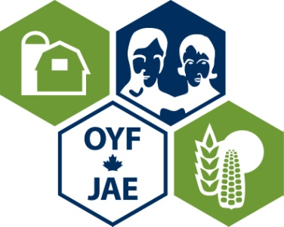
Sponsorship Opportunities
Saskatchewan Outstanding Young Farmers Program

This program is administered by volunteer alumni members and the generous contributions of industry sponsorship as outlined below: Thank you for your consideration.

Charter sponsors will be given the highest profile within the program of events and are encouraged to become partners in the program through an advisory role. Contributions "in-kind” are also welcome and will be given the appropriate designation based on a value deemed by the sponsorship committee.

Charter Sponsors
Up to 3 sponsors- each has a 3 Year Term
$5000 /year

Platinum Plus Sponsor
$2500

Platinum Sponsor
$1000

Gold Sponsor
$500

Silver Sponsor
$250

BENEFITS TO YOU THE SPONSOR:
Use this Outstanding Young Farmers Sponsorship Opportunity to:
    - Promote your customers. Nominate a customer that fits the criteria of an Outstanding Young Farmer
    - Increase you company’s profile with this group of top-quality producers
    - Associate your business with these successes and examples of excellence and innovation in agriculture
    - Network with “cream of the crop” producers that are on the cutting edge of the industry
    - Use this resource for focus group studies, research and development. These farmers are innovative, creative, and effective operators who have a recognizable profile in their community.

Sponsorship contact:
Elaine Pruim
Regional Coordinator
Email: elainepruim@live.com
Tel: 306-239-4263

Outstanding Young Farmers’ Program
Saskatchewan
2019 Regional
Sponsorship Levels

Sponsorship  Benefit | Silver  $250 | Gold  $500 | Platinum  $1000 | Platinum Plus  $2500 | Charter  $5000/year  For 3 years
Exclusivity Of Category |  |  |  |  | *****
Opportunity To Speak At Banquet |  |  |  |  | *****
Presentation Of Trophy To Winners (alternating between sponsors) |  |  |  |  | *****
Invitation To Summer Annual Dinner And Meeting |  |  |  |  | *****
Invitation To Fall Annual Dinner And Meeting |  |  |  | **** | ****
Invitation To Thursday Night Alumni Social During Regional Event |  |  | *** | *** | ***
Promotion By Annual Winners At Speaking Engagements |  |  | *** | *** | ***
Recognition In Hospitality Suite |  | ** | ** | ** | **
Recognition At Banquet | * | * | * | * | *
Recognition In Banquet Program | * | * | * | * | *
Name On Sponsor Board And Website | * | * | * | * | *
Identify Potential Nominees To Committee | * | * | * | * | *
Number Of Banquet Tickets | 2 | 4 | 8 | 12 | 16
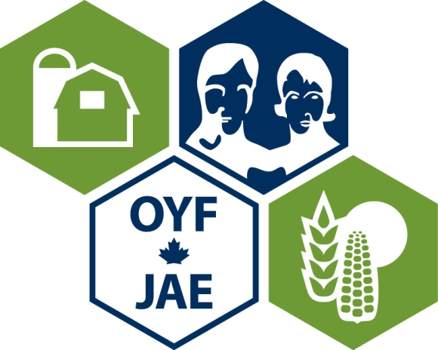

Sponsorship Indication Letter
Saskatchewan’s
Outstanding Young Farmers Program

We confirm our participation as a sponsor of the 2019 Outstanding Young Farmers Program at Canada’s Farm Progress Show on June 20th, 2019 to be held at the Exhibition Grounds, Regina, SK.

______________________________________________________
(Name of Company)

Level Of Sponsorship  (please check the appropriate option) | Price | Choice  (please check)
Silver | $250
Gold | $500
Platinum | $1000
Platinum Plus | $2500
Charter | $5000 / year  for 3 years

Please direct all correspondence to:
Contact Person
Alternate Contact
Address
Phone/Fax Number(s)
Email
Date
Signature
Make cheques payable to :

Saskatchewan Outstanding Young Farmers
c/o Elaine Pruim
Box 400
Osler, SK S0K 3A0

Phone: 306-239-4263 Fax: 306-239-4267
Email elainepruim@live.com

